1. **Git and Github is a version control system. It addresses the issue of sharing and versioning.**
2. **Old version control systems are as follows,**

**CVS**

**SVN**

**These are centralized version control system while Git is distributed version control system.**

1. **I.Q: Distributed v/s Centralized**
2. **I.Q: What is a fork?**

**Fork means creating an entire copy of your original source. This way code is distributed and not in a single place. Multiple copies I mean. It is to avoid the single point of failure.**

1. **I.Q: Difference between Git and Github.**
2. **How to download and install git.**

[**https://git-scm.com/download/linux**](%20https:/git-scm.com/download/linux)

1. **Three commands that every devops engineer should know,**

**#git add**

**#git commit**

**#git push**

1. **To create or initiate git repository.**

**#cd /home/xyz**

**#git init**

1. **Everything in Git is track as a objects.**

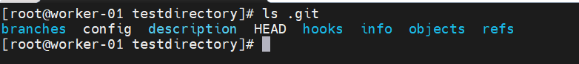

1. **Using hooks you can prevent committing the passwords or API tokens.**
2. **Config used to configure your git credentials for secure git login, TLS etc.**